Attachment 2

Draft Map Options and Demographic Data

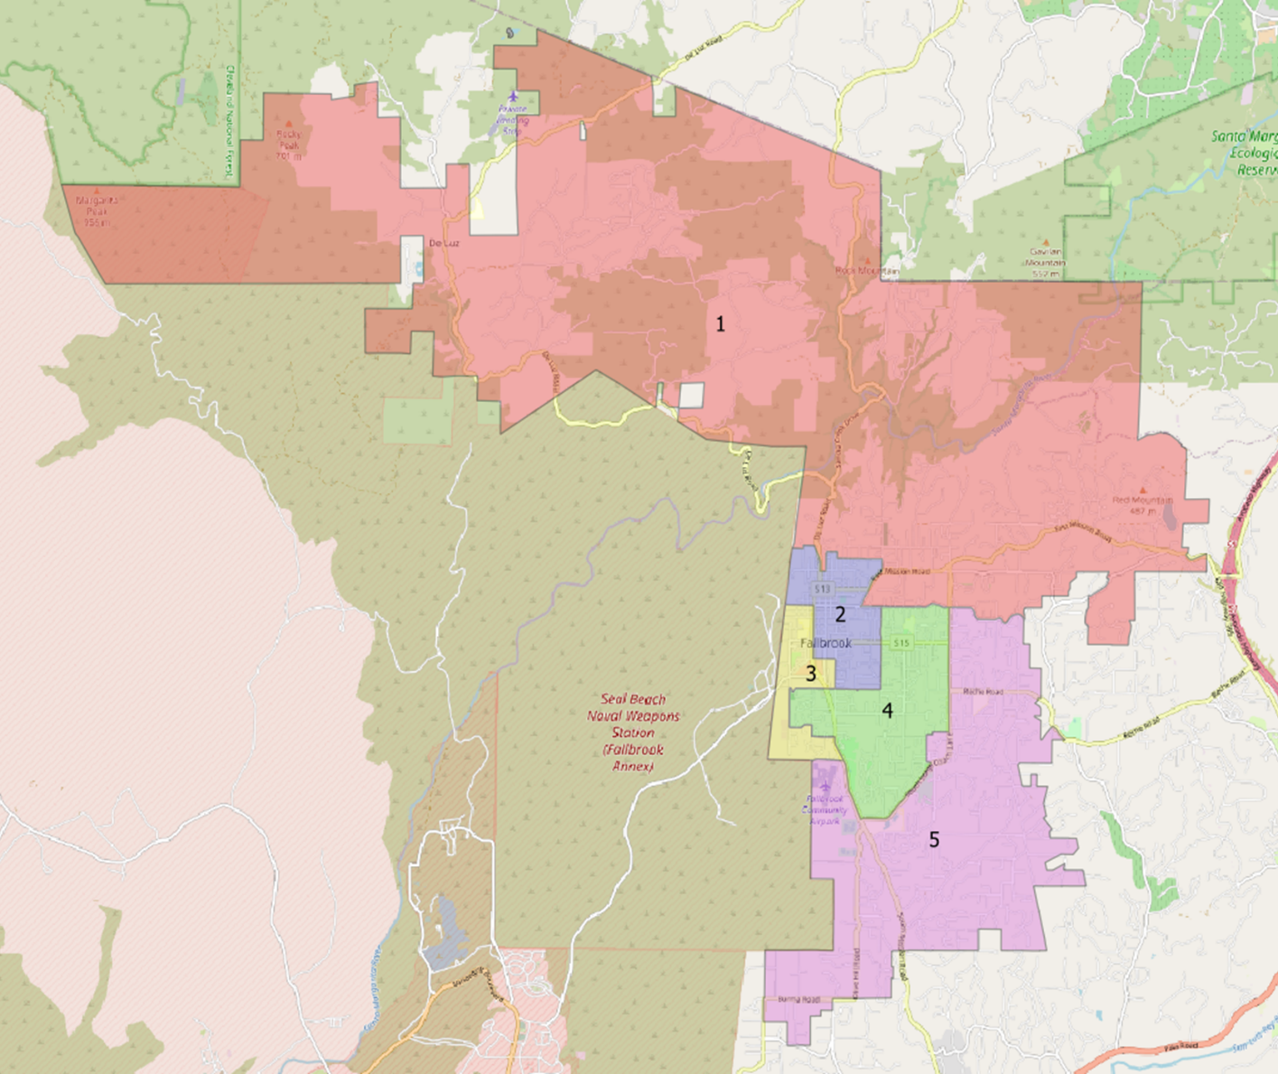Map Option1

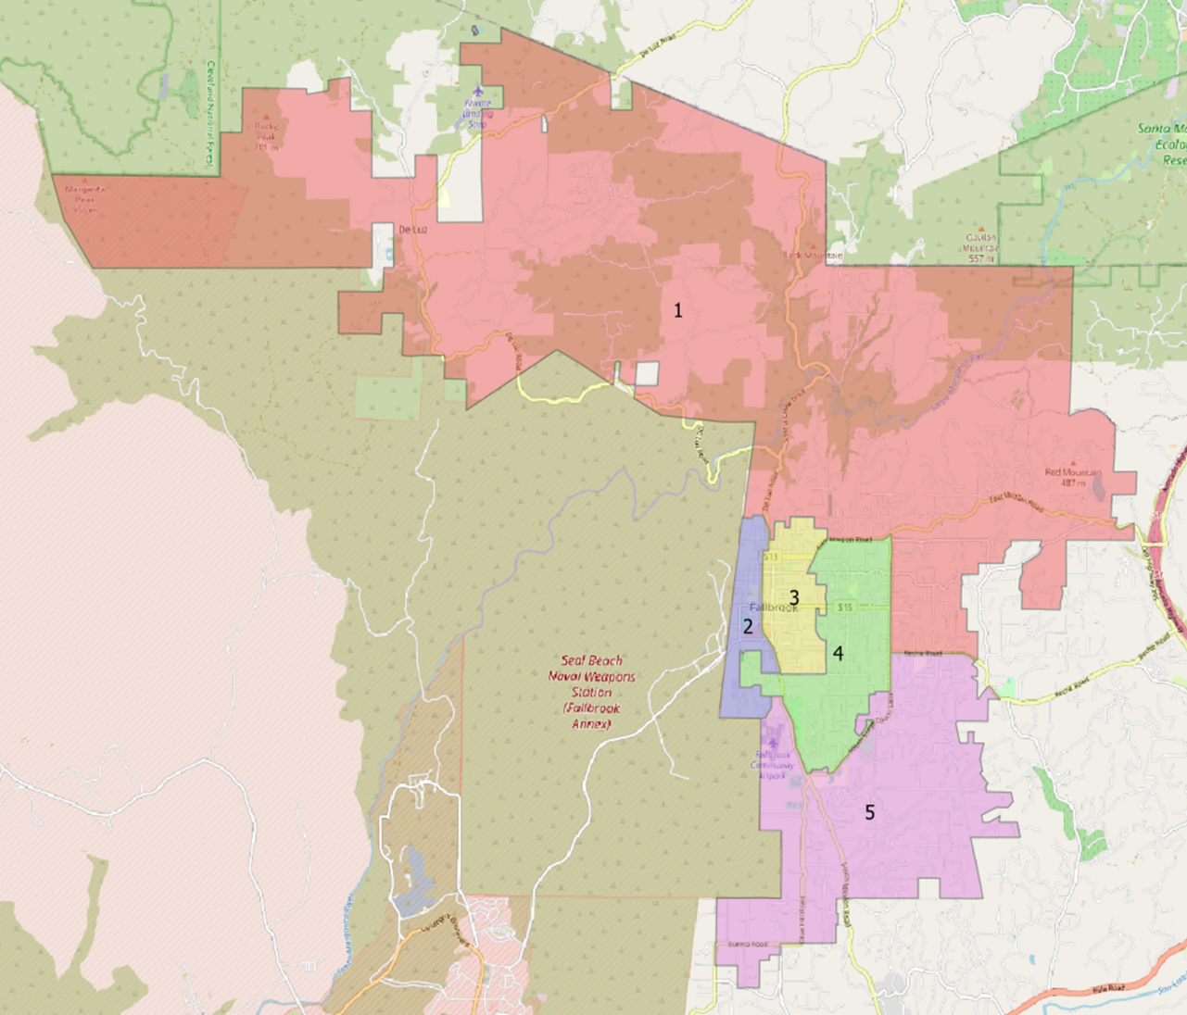Public Map Option A